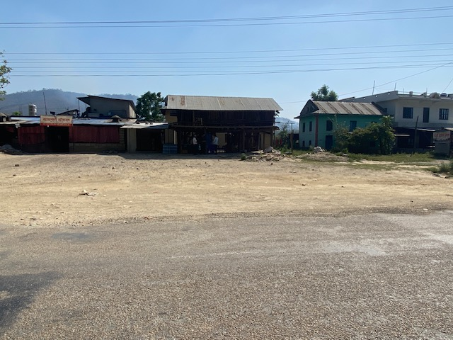

**Plot No. 182 ( 3081.53 Sqm ) . Location –Khaskushma -08,Banke**

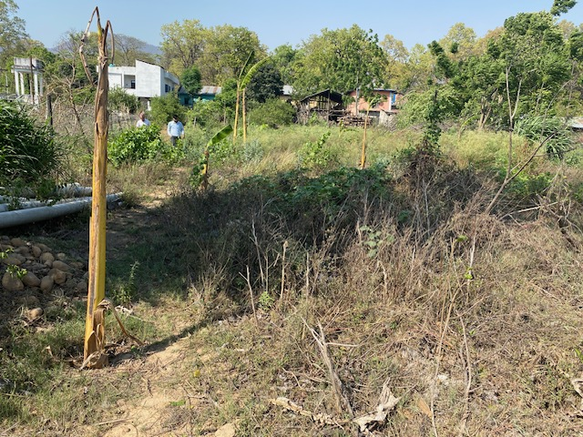

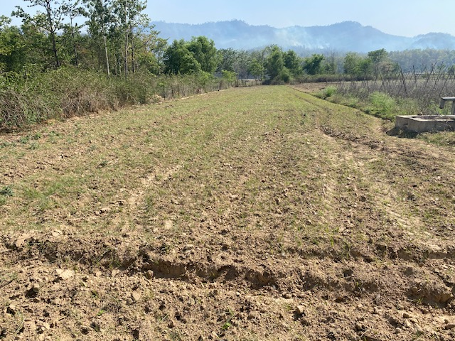

**Plot No. 35 ( 6366.22 Sqm) ,144( 2074.11 Sqm ) ,143 ( 1693.15 Sqm) ,142 ( 1693.15 Sqm) & 141 ( 1693.15) . Plots are adjoined. Location – Khaskushma -08,Banke**

